INJECTION ANATOMY OF THE FACE

The head is full of blood vessels so why would anyone want to inject blindly?
BUT WE DO !
The important thing is to make sure you are either above or behind the vessel and not inside when you inject.
When injecting near vital structures its critical to know the depth of the needle tip.

If an intravascular injection occurs, if the pressure on the plunger exceeds systolic pressure the product will flow in the direction of least resistance which may be retrograde to the flow
When pressure on the plunger is released the product will flow anterograde. It is no longer where you injected it and it will flow forwards clogging distal vessels

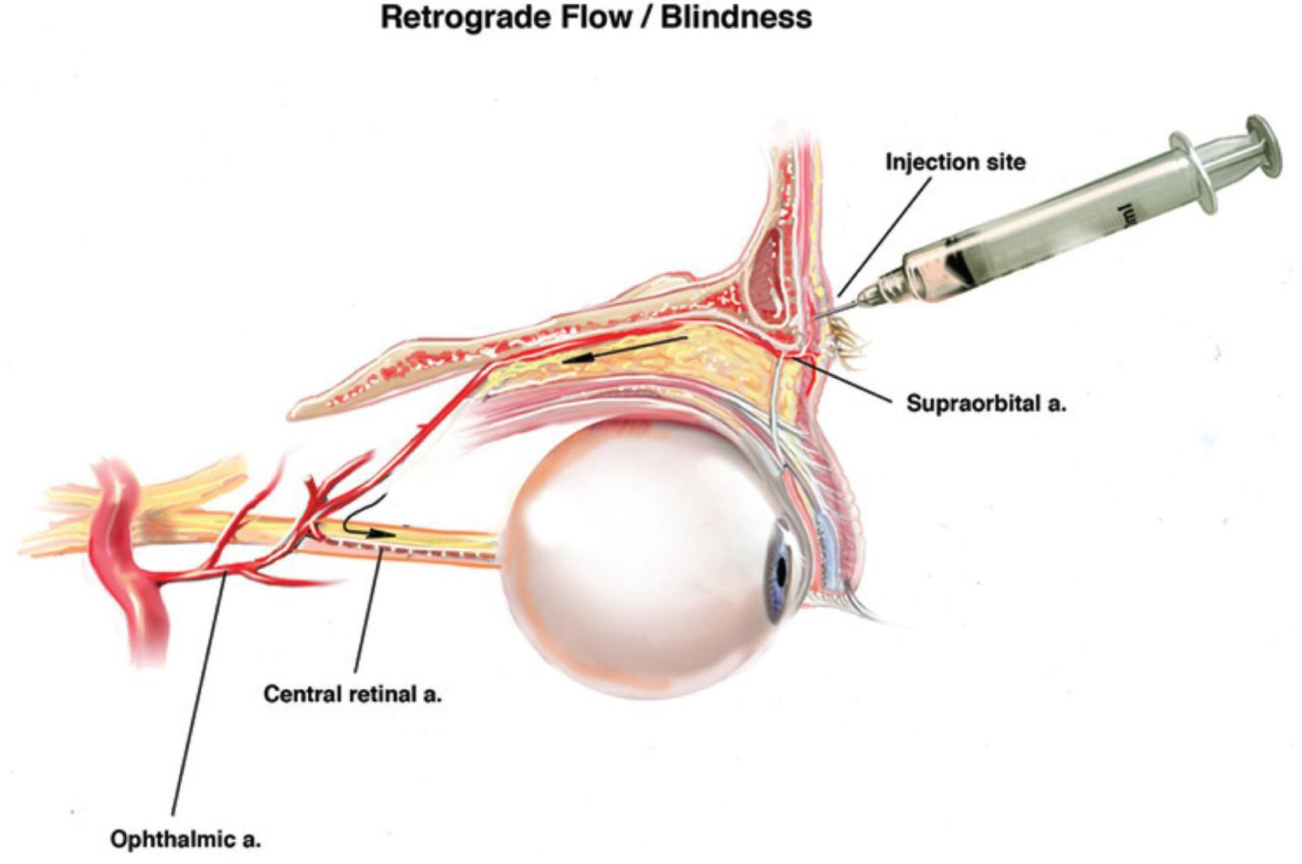

Prevention is better than cure
- Knowing where the tip of the needle is crucial
- Aspiration may point to the needle tip being intra-arterial
- Low pressure injections-trying to keep pressure below systolic pressure
- Slow injection may give you time to react
- Low volume may reduce the risk of larger arterioles being blocked-smaller amounts of product are more likely to be broken up.

DANGER AREAS

The highest cases of reported skin necrosis and blindness have occurred following injections in,
1. The Glabella Region
2. The Nose
3. The Tear Trough
4. The Upper Nasolabial fold

That is THE CENTRAL PART OF THE FACE

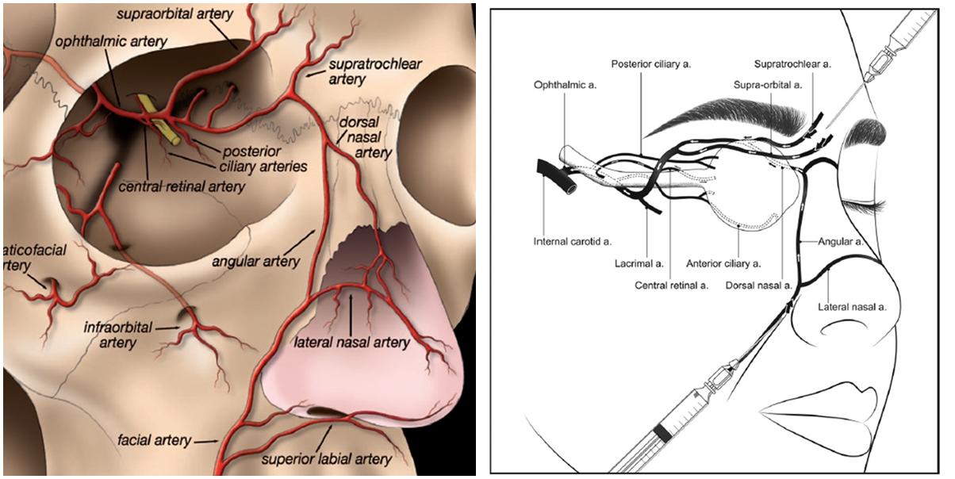

The vascular anatomy of the face is too complex and varied to know precisely whether an artery is running slightly to the left of the right of where it appears in the anatomy books.
What is more predictable in the DEPTH of the vessels in specific regions.

GLABELLA REGION

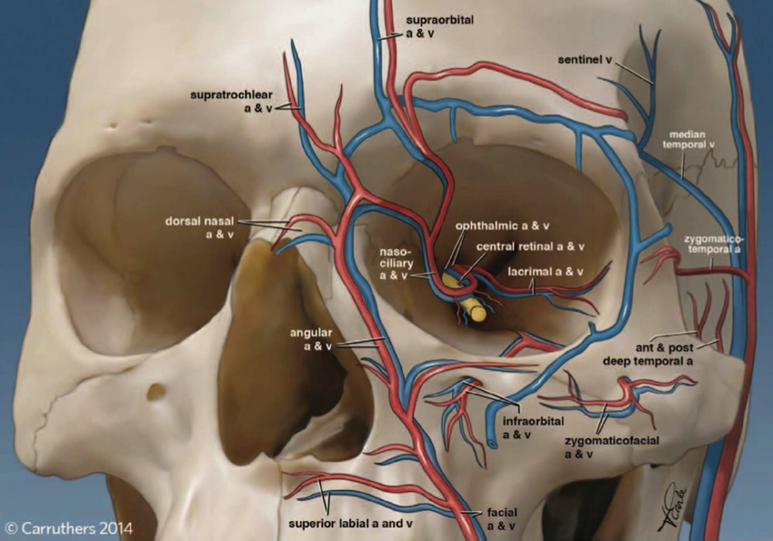

In the upper face the supraorbital and supratrochlear arteries provide the main blood supply to the forehead

We have surface landmarks that can help us
- Supraorbital notch-in line with the medial iris. The supraorbital artery arises here on the rim and is a consistent finding. It is an extension of the ophthalmic artery.
- The supratrochlear artery is more variable emerging 8-12mm medial to the supraorbital artery. The most medial frown line overlies this artery

Both arteries emerge deep heading upwards, branching in any direction.
We have no idea of their exact path but we do have an understanding of their depth in specific regions. Both arteries emerge deep, passing over the corrugators running deep to orbicularis oculi and frontalis.
Within the first 1.5-2cm these arteries will perforate the galea (which is the deep fascia on the undersurface of frontalis) pushing towards the surface of the muscle.

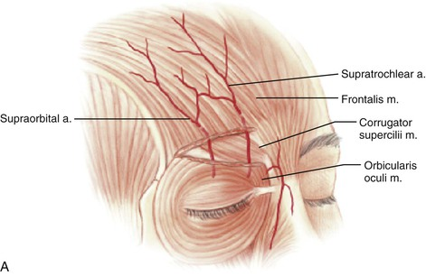

When injecting the lower glabella within 2cm of the orbital rim inject SUPERFICIAL

When injecting above this inject DEEP on the bone.

Use a soft product, small volumes and inject slowly.

TEMPORAL REGION

The temporal fossa houses the temporal muscle. High up the muscle is firmly adherent to the bone.

The frontal branch runs superficially between the superficial and deep temporal fascia as does the frontal portion of the temporal branch of the Facial Nerve.

The deep temporal arteries (which are branches of the maxillary artery lie deep but terminate posteriorly.

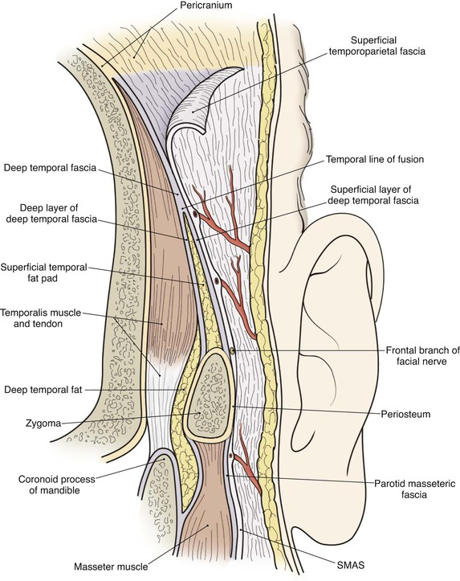

A safe injection point here would be to inject DEEP on the bone.
About 1cm up from the orbital rim and 1cm lateral to the temporal fusion line.
Here the muscle is about 5mm deep. Make sure you can palpate the superficial temporal artery.
Inject up to about 0.5ml of a high G prime filler.
The injection will effectively be intramuscular and the lift is achieved by the tenting of the deep temporal fascia.
A superficial injection can be made if a wider contouring effect is required. Cannula here is the only option.
Remember you may see some prominent superficial veins after the procedure and the patient may have some discomfort on eating for 24hrs or so.

TEAR TROUGH REGION

Tear trough deformity is a major concern in a lot of individuals seeking periorbital rejuvenation. A prominent tear trough deformity is characterised by a sunken appearance of the globe that results in the casting of a dark shadow over the lower eyelid, giving the patient a fatigued appearance despite adequate rest, and is refractory to attempts at cosmetic concealment.
The “tear trough” refers to the medial one- third of the periorbital hollow, and in early aging, it may be the only area of concavity visible (Fig. 1). The tear trough is not exclusively the product of age. A mild trough is seen in youth in many individuals. It is the deepening of this groove that leads to true indentation and significantly impacts facial appearance.
Dark circles are often a result of tear trough deformity. However, the causes of dark circles can be multi-factorial. Changes in skin thickness, laxity, hyperpigmentation and actinic changes also play a role. Thin skin or prominent subcutaneous venous pooling accentuates the periorbital darkening.
Additionally, prolapse of orbital fat may indirectly cause a shadowing over the lower lids

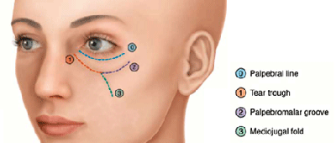

The tear trough deformity is a natural consequence of the anatomic attachments of the periorbital tissues.
Predisposing factors include:
- Fixation of the orbital septum
- Descent of the cheek fat pad medially
- Loss of volume in the malar complex
- Descent of the globe with age and anterior projection of the infraorbital fad pad
- Skin laxity

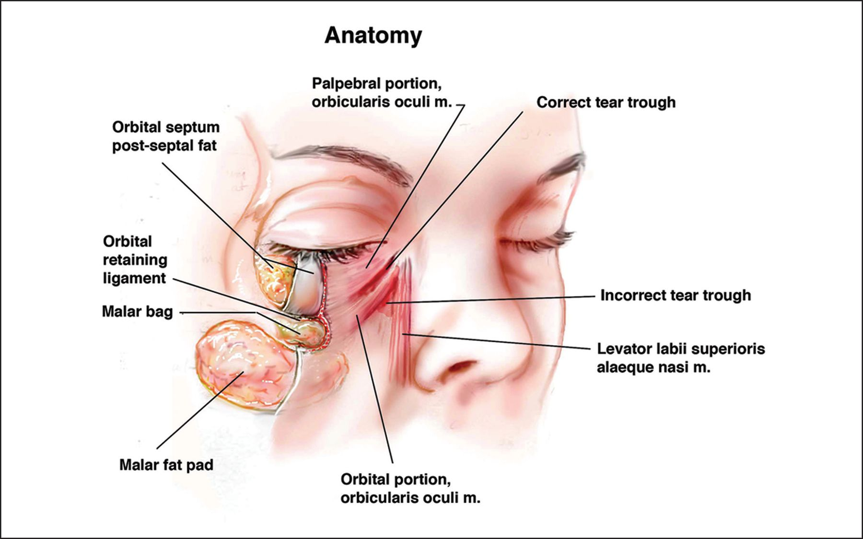

Volume loss at the orbital rim is of course not an isolated aging event. In truth, it is part of a volumetric involution that occurs globally in the Clinically, the periorbital pattern of volume loss can be categorized into three classes

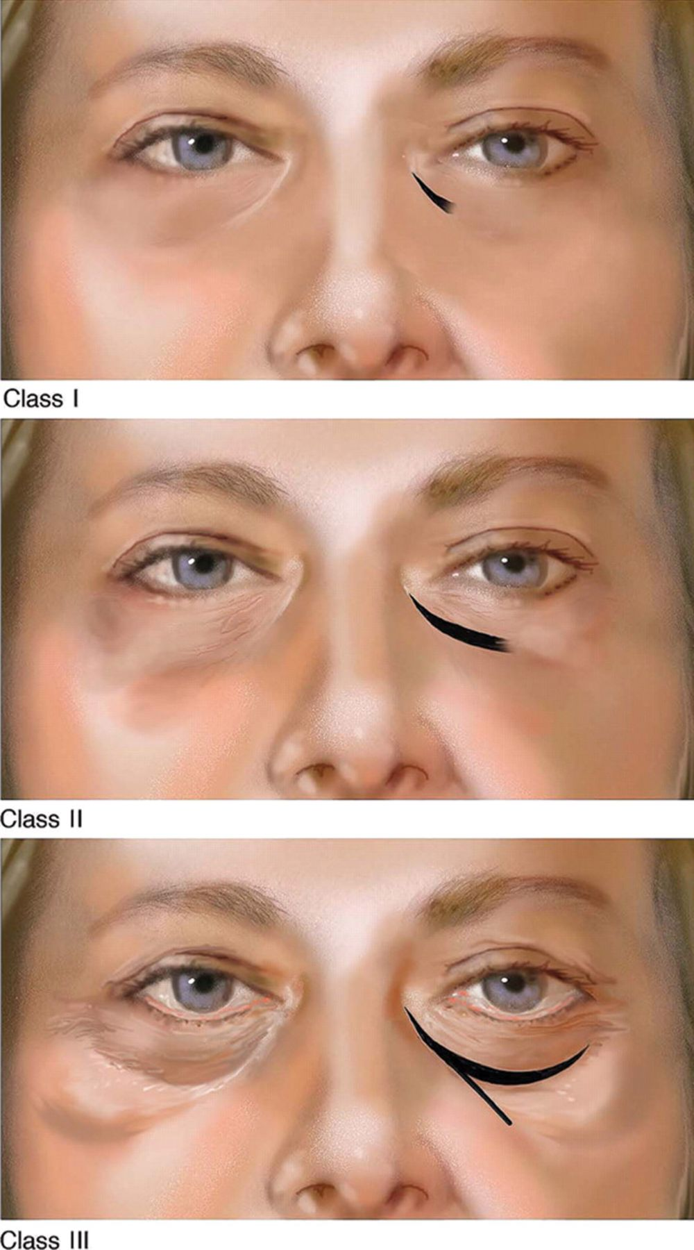
Classification of the patterns of periorbital volume loss: class I, limited to the tear trough or medial orbit (sometimes associated with very mild flattening of the central cheek); class II, medial and lateral depression apparent (can be associated with mild volume deficiency in the medial cheek and mild flattening of the central triangle; and class III, full depression visible circumferentially at the orbital rim (often associated with more advanced volume deficiency in the medial cheek, central reverse triangle/midface and malar eminence, and the oblique mid-cheek crease highlighting the malar bags).

CONTRAINDICATIONS

- Unrealistic expectations
- Infection near the site of injection
- Known allergy or hypersensitivity to the material or to the lidocaine mixed in the syringe of the filler
- Patients with septal fat herniation
- Severe elastosis (e.g., dermatochalasis or large eye bags)
- Patients with early morning swelling

Patient selection is critical to obtaining good results. The best candidates are patients with good skin tone and minimal skin laxity, with mild to moderately deep tear troughs.
Patients with very thin or transparent skin, those with significant skin laxity, and those with extremely deep tear toughs are poor candidates.
PRECAUTIONS

- Vitamin E, gingko biloba, aspirin and nonsteroidal anti-inflammatory drugs (NSAIDs) should be avoided at least five days before the treatment to prevent bruising.
- Care should be taken in patients with a history of lower eyelid blepharoplasty without lateral retinacular suspension.
- One should be cautious while injecting around the infraorbital foramen to avoid injury to the neurovascular bundle.
- Careful and gentle moulding of the implant for a more homogeneous distribution of the material is encouraged after injection to obtain an even distribution of the filler in the lateral part of the hollow.

Key points for tear trough injection

- Low-viscosity HA can be safely injected to correct tear trough deformity. High-viscosity HA and non-biodegradable agents should not be injected in the tear trough area.
- Injections must be at a supra-periosteal level of the orbital rim under defect.
- One should be cautious around the infraorbital foramen.
- The HA filler should be gently massaged for even distribution; strong massage should be avoided.
Overcorrection should be avoided. HA is hydrophilic and may cause a swelling due to its property of attracting water. Hence, it is best to under-correct the tear trough area to prevent bulges under the eye. A touch can always be done if necessary when the patient comes for a follow up.

COMPLICATIONS
Immediate complications

- Pain (HA fillers with lignocaine, for example, are more comfortable for patients as the pain is alleviated)
- Erythema
- Swelling and bruising (this can be minimized by applying firm pressure and ice packs before and after the treatment session)
- Asymmetry
- Migraine

Delayed complications

Orange-brown staining
Injection of the tear trough or periorbital region with any dermal filler may also be associated with bruising and subsequent deposition of hemosiderin, giving an orange-brown or rusty, stained appearance to the skin that may take months to resolve on its own. Pre-injection ice application, proper depth of injection, discontinuation of anticoagulants at least seven days before injection, and a smooth, gentle technique may help avoid this complication.

Post-inflammatory hyperpigmentation
It is often seen in darker skin types due to bruising and haematoma. It may last for a very long period and can be difficult to treat

Puffiness
Overcorrection with HA products in the periorbital area also may cause a puffy, oedematous appearance of the lower eyelids because of the hydrophilic nature of the filler. The oedema may seem to wax and wane, fluctuating in patients with allergic predispositions or in response to dietary intake of salt. Caution should be exercised when approaching patients with festooning (the small bag-like protrusions usually located at the inferior-lateral aspect of the lower eyelids/upper cheek) or in areas of lymph-oedema when using HAs. HAs are highly hydrophilic and may exacerbate the condition.

Infections
Though extremely rare, they can present as single or multiple erythematous and fluctuant nodules that are best treated with antibiotics active against frequent skin bacteria including Staphylococcus epidermidis or Propionibacterium acnes. Filler injections should not be performed if there is an infection in the adjacent site.

The tyndall effect
HA when injected too superficially can lead to a bluish discoloration under the skin. This bluish discoloration is due to the Tyndall effect where the blue light spectrum is scattered by the colloid particles more strongly.

Nodules
Nodules can occur with superficial infections. They can be treated with local massage, aspiration or incision and drainage of the product. Hyaluronidase can be used to dissolve a nodule or a focus of overcorrection in the case of HA-based fillers. However, a preliminary skin test is necessary to rule out an allergic reaction to hyaluronidase.

Blindness
Although extremely rare, this may be an under-reported complication. According to Coleman, blindness occurs due to migration of a filler embolus in a retrograde manner via an arteriole to an anterograde flow through the central retinal artery. Hence it is important to limit the amount of filler bolus injected in one site. One way to do this is to use blunt cannulas. The possibility of blindness also can be minimised by moving the needle tip, and by injecting slowly, with minimal pressure and minute quantities of the filler at a time.

The key to aesthetic correction of the tear trough is to think beyond the tear trough. Depending on the depth and extent of volume loss, further injections are indicated to correct the central and lateral aspect around the orbital rim and all adjacent areas. Typically, there is a flattened area centrally in the shape of a reverse triangle that should be filled. The medial cheek, if left deflated, will contribute to an unnatural appearance, especially with facial expression.
To quote Glaser et al., “The aesthetically attractive lower eyelid should display a relatively smooth transition between the pre-septal and orbital portions of the orbicularis oculi muscle and continue into the upper malar region without a definable transition point.”

NOSE REGION
Rhinoplasty is re-shaping of the nose which can be done surgically or no-surgically (NSR)

Benefits of NSR
- Ideal for patients who do not want surgery or are unfit.
- Can address congenital and acquired defects
- Minimally invasive
- Less expensive
- Fewer complications
- Reversible
- Minimal downtime
- Generally satisfactory results

Disadvantages of NSR
- Non-Permanent
- Limited range of applications
- Risk of skin necrosis
- Can’t be used when reduction is required (Remember we are actually adding volume)

Deformities that can be corrected by NSR
- Minor humps and bumps
- Tip depression
- Pinched tip
- Wide bridge
- Saddle deformity
- Minor asymmetries

REMEMBER FOLLOWING SURGERY THE ANATOMY MAY HAVE ALTERED AND SO RISK OF VASCULAR COMPROMISE AND NECROSIS IS SIGNIFICANT

Surface Anatomy of Nose

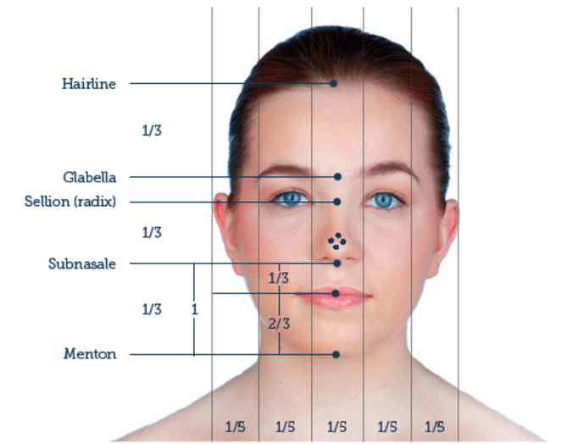
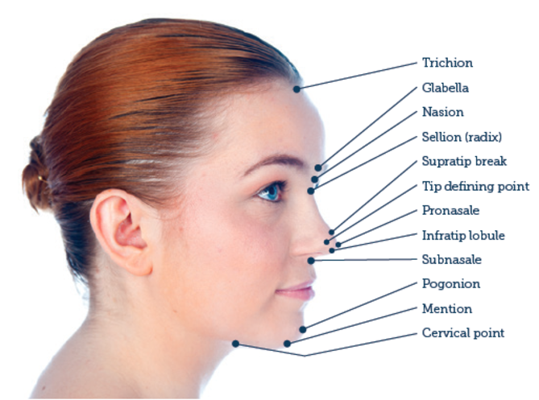

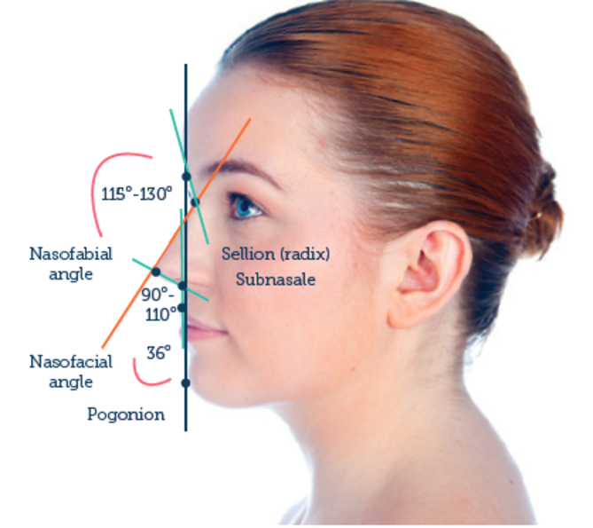

Vascular Anatomy of Nose

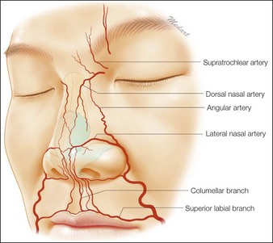

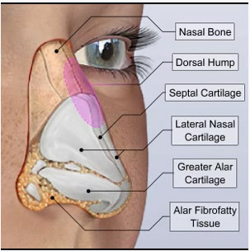

Signs of Intra-arterial Injection
- Excessive pain
- Blanching of skin
- Livedo-blotchiness
- Poor capillary refill

MANAGEMENT
- Hyalase
- Hot compresses
- Massage
- Aspirin

Remember we can also use toxin for bunny lines, dilated nostrils and top help lift tip of the nose.

NASOLABIAL REGION

Nasolabial injection with HA fillers are some of the most commonly performed aesthetics procedures and an area that is taught on most Foundation Filler courses.
This implies that this is a safe area to inject.
Clearly this is not the case given the incidence of alar and lip necrosis and risk of blindness.
The reason for this is the close proximity of the Facial Artery.

The FA is a branch of the external carotid artery and winds itself around the mandible anterior to the masseter muscle. Is can sometime be palpable there being approximately 1cm in front of the anterior border.
From there it winds a tortuous route running between 8-18mm lateral to the oral commissure and then ascending to run in 3.2mm+/- 4.5mm lateral to the alar triangle.
This implies quite a variability the higher up you go.

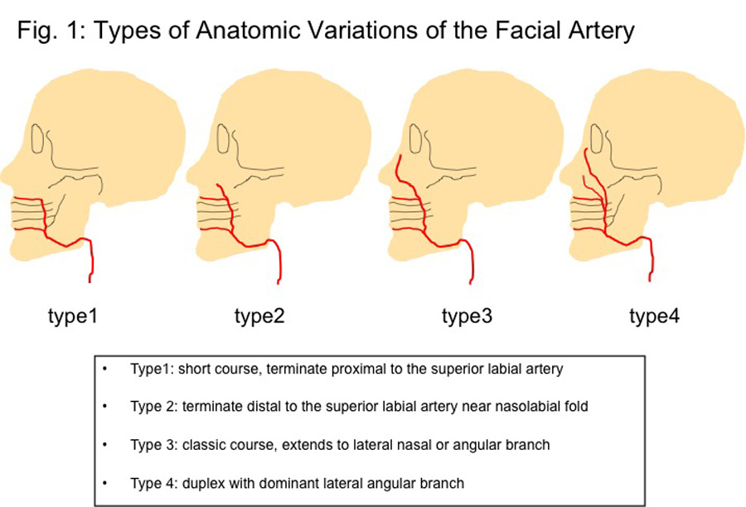

This variability is worrying and difficult to predict.
Intravascular injection can result in necrosis of the lateral side of the nose (occlusion of the lateral nasal artery) , necrosis of the top lip ( occlusion of the superior labial artery or its branches) and potential blindness (occlusion of the central retinal artery by bolus HA)

What is more predictable is the depth of the artery in certain anatomical areas.

As the FA emerges onto the face it is deep on the bone of the mandible.
As it ascends it traverses deep to DAO and the zygomaticus muscles but then become more superficial emerging above the lip elevators.

This would indicate that we have a number of options in this area
- Don’t treat-think about volume replacement higher up in the face.
- Use a cannula-hopefully this will avoid intraarticular puncture and injection
- If using a needle think about possibly injecting perpendicular to the nasolabial fold-this could reduce the risk of cannulation
- When injecting in the ala triangle either inject superficial or alternatively deep down on the bone.

REMEMBER ALSO

- ASPIRATE
- INJECT SLOWLY
- SMALL AMOUNTS
- WATCH FOR POTENTIAL PROBLEMS e.g. BLANCHING, PAIN, FLASH BACK IN THE NEEDLE

JAWLINE REGION

Rejuvenation of the jawline is now increasingly becoming part of routine aesthetic practice. The ideal youthful appearance is of a straight line that clearly defines the face-neck junction. The two main aesthetic concerns are the development of a jowl and blunting of the jawline definition. Jowl formation is a multifactorial process with contribution to the descent of tissues from the subcutaneous compartment, caused by laxity of the fibrous septae and herniation of fat compartments, superficial musculo-aponeurotic layer (SMAS) and sub-SMAS laxity, and descent of the buccal fat pad.⁸ Bony resorption of the pre-jowl area of the mandible accentuates the appearance.

The overall blunting of the jawline is caused not only by the jowl, but also has contribution from the pull of platysma, the development of submental fat, and the bony changes that effect the mandible, namely loss of height of the mandibular ramus, loss in height of the mandibular body, and increase of the mandibular angle.

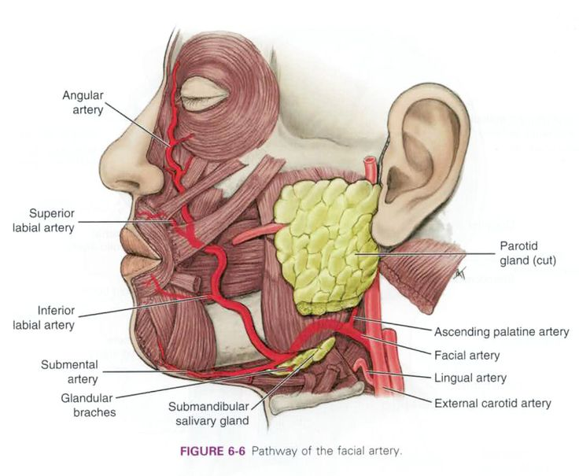

FAT PADS OF FACE

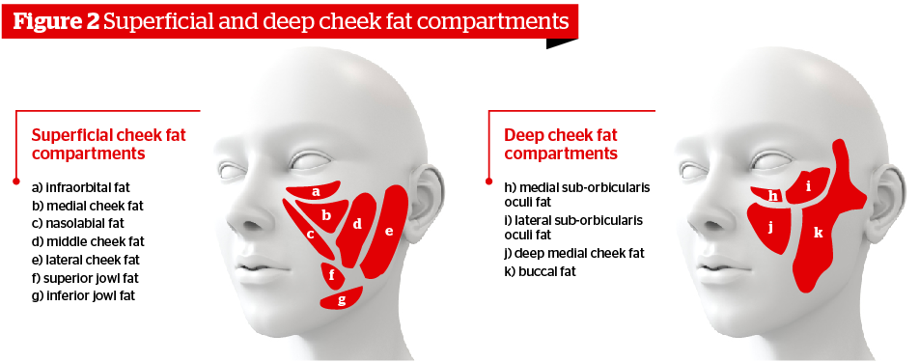

Ageing of the face is characterized by different phenomena happening at more or less the same time: Variable skin atrophic changes and wrinkle formation caused by genetic, actinic, and environmental factors; bone volume and facial fat loss; and skin sagging.
Volume loss takes place mostly in the bony skeleton and fat compartments with predictable patterns.
With ageing, the bony layer undergoes a reabsorption of the skeleton, mostly in the orbital, periorbital, malar, sub-malar, and mandibular areas.

The fat compartments follow a rather predictable pattern of depletion. In the deep supra-periosteal layer, most of the volume loss takes place in the lateral and medial sub-orbicularis oculi fat, the deep medial cheek compartment, and the chin fat compartments.
In the superficial subcutaneous layer, most of the volume loss takes place in the lateral compartments, both in their temporal and pre-auricular districts and to a lesser extent, in the middle and medial fat compartments of the superficial cheek fat pad.
All the areas of fat reabsorption are confined in between the ligaments, so that on the surface of the skin, several grooves become identifiable with the volume deflation.

